- A viewpoint would be described as:
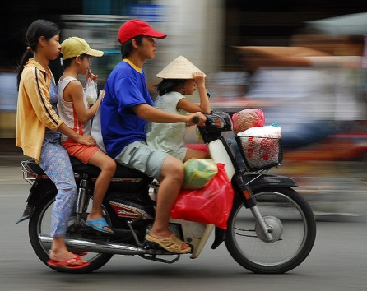
  - The eyepiece in which one looks through to take the photo
  - The position or location from which a photograph is taken.
  - The numerical representation of the diameter of a lens’s aperture.
  - A flexible wire extension attached to the shutter release.
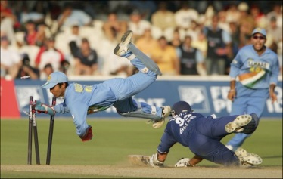
- This photo would be a good example of:
  - Freeze
  - Blur
  - Panning

- Your camera mode dial is set on TV. It is a sunny day. ISO is set at 100. You are at the Daytona 500. You get to stand in the pit with the crew and watch the cars go by. You want to get a freeze shot. Where would you set your shutter speed?
  - 1/250
  - 1/60
  - 1/15
  - 1/1000
- To freeze HUMAN motion, the best speed would be
  - 1/60
  - 1/100
  - 1/250
  - 1/500
- On your mode dial, TV stands for
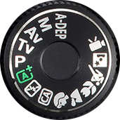
  - Aperture Priority
  - Shutter Priority
  - Program
  - Television

- This photo would be a good example of
  - Panning
  - Freeze
  - Blur
- It’s a cloudy day, but there is a little light. You are at a baseball game and you want to get a panning photo of someone sliding into home plate. If your camera has the following settings – WB – Cloudy, ISO 200, Mode Dial TV, Continuous shooting, AI Servo – where would you likely start your shutter speed?
  - 1/1000
  - 1/60
  - 1/250
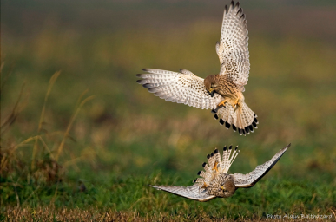
  - 1/30
- This photo is a good example of
  - Panning
  - Freeze
  - Blur

- Outside of Movement and Rhythm, what is the next strongest design principle you will get with panning?
  - Emphasis
  - Value
  - Line
  - Contrast

- Which type of action photography requires you to move the camera with the moving object?
  - Freeze
  - Blur
  - Panning

- You have a new 135mm lens. What would be the lowest shutter speed that you would set your camera on to avoid “hand-shake” if your shutter speed options are: 1/40, 1/60, 1/80, 1/100, 1/125, 1/140, 1/250, 1/400?
  - 1/80
  - 1/125
  - 1/140
  - 1/400

- The best type of lens for action photography is
  - 55mm (normal)
  - 28mm (wide angle)
  - 135mm (zoom)
  - 70-300mm (telephoto)
- This flash that helped take this photo was made by a man by the name of Edgerton. The speed of the flash was
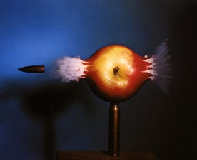
  - 1/100,000
  - 1/1000
  - 1/300,000
  - 1/3000

- The built-in flash in our cameras is good for sports photography.
  - True
  - False
- What makes a good “blur” motion photo?
  - Slow shutter speed, move camera with moving object
  - Fast shutter speed, high fstop
  - Slow shutter speed on stationary objects.
  - Slow shutter speed on a tripod. Moving object is blurred and background/foreground is steady.
- The four types of blur that we read about are
  - Camera motion blur, subject motion blur, out-of-focus blur and depth of field blur.
  - Camera motion blur, panning, freeze, depth of field
  - Depth of field, shallow depth, large depth, Freeze
  - Camera motion blur, subject motion blur, depth of field, freeze
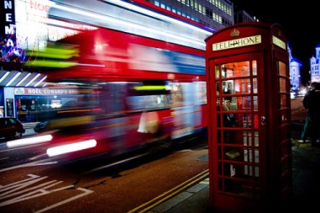
- This image is a good example of
  - Blur
  - Freeze
  - Panning

- This image is a good example of
  - Blur
  - Freeze
  - Panning

- Which photo is panning?

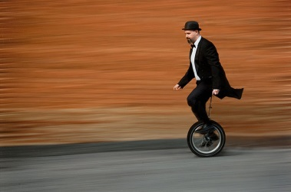
- 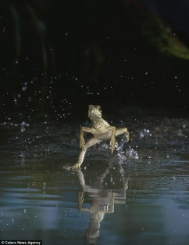 b.

- You are at a dance festival in Tradition on a sunny day. You have a ladder and you want to stand above one of the twirling dancers to get a blur shot. Which setting below would be most appropriate.
  - AV, FSTOP 4.0, Fluorescent lighting, ISO 3200
  - P, FSTOP 4.0, ISO 400, Cloudy
  - M, FSTOP 4.0, ISO 100, Sunny, Shutter speed 1000
  - TV, Shutter speed 30, ISO 100, Daylight

